Inductive Transducer Working & Its Applications
Inductive Transducer is the self-generating type otherwise the passive type transducer. The first type like self-generating uses the principle of fundamental electrical generator. The electric generator principle is when a motion among a conductor as well as magnetic field induces a voltage within the conductor. The motion among the conductor and the field can be supplied by transforms in the measured. An inductive transducer (electromechanical) is an electrical device used to convert physical motion into modifying within inductance. This article discusses what an Inductive Transducer, types of transducer, working principle, and its applications

Types of Inductive Transducer
There are two kinds of inductive transducers available such as simple inductance & two-coil mutual inductance. The best example of an inductive transducer is LVDT. Please refer to this link to know about inductive transducer circuit working and its advantages and disadvantages such as LVDT (linear variable differential transformer).
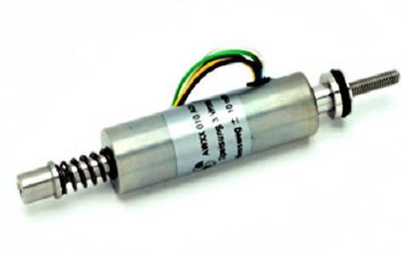
inductive-transducer

1). Simple Inductance
In this type of inductive transducer, a simple single coil is used as the transducer. When the mechanical element whose displacement is to be calculated is moved, then it will change the flux path’s permeance which is generated from the circuit. It modifies the inductance of the circuit as well as the equivalent output. The circuit o/p can be directly adjusted against the input value. Therefore, directly it provides the parameter’s valve to be calculated.

2). Two-Coil Mutual Inductance
In this type of transducer, there are two different coils are arranged. In the primary coil, the excitation can be generated with external power source whereas in the next coil the output can be attained. Both the mechanical input as well as output are proportional.

Inductive Transducer Working Principle
The working principle of an inductive transducer is the magnetic material’s induction. Just like the electrical conductor’s resistance, it depends on various factors. The magnetic material’s induction can depend on different variables like the twists of the coil over the material, the magnetic material’s size, & the flux’s permeability.
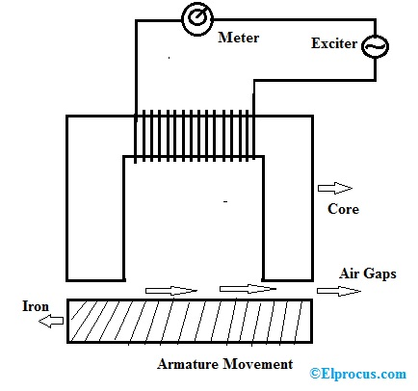inductive-transducer-working
The magnetic materials are used in the transducers in the path of flux. There is some air gap between them. The change in the circuit inductance can be occurred due to the air gap change. In most of these transducers, it is mainly used to work the instrument properly. The inductive transducer uses three working principles which include the following.
- Self Inductance Change
- Mutual Inductance Change
- Eddy Current Production

Self Inductance Change
We know that the coil’s self-inductance can be derived by
L = N2/R
Where ‘N’ is the number of twists of coil
‘R’ is the magnetic circuit’s reluctance
The reluctance ‘R’ can be derived by the following equation
R = l/µA
Thus, inductance equation can become like the following
L = N2 µA/l
Where
A = It is the Coil’s cross-sectional area
l = Coil’s length
µ = Permeability
We know that geometric form factor G = A/l, then the inductance equation will become like the following.
L = N2 µG
The self-inductance is changed by a change in the number of twists, geometric form factor ‘G’ and permeability ‘µ’.
For instance, if some displacement is capable to alter the above factors, then it can be calculated directly in terms of inductance.

Mutual Inductance Change
Here transducers work on the principle of change in mutual inductance. It uses several coils for the purpose of knowing. These coils include their self-inductance which are indicated by L1 & L2. The common inductance among these two twists can be derived by the following equation.
M = √ L1. L2
Therefore common inductance is altered by unstable self-inductance otherwise through the unstable coupling of coefficient ‘K’. Here, the coupling coefficient mainly depends on the direction & distance among the two coils. As a result, the displacement can be measured by fixing one coil & make secondary coil movable. This coil can move by the power source whose displacement is to be calculated. The change in mutual inductance can be caused by the change in displacement coefficient coupling distance. This mutual inductance change is adjusted by measurement and displacement.

Eddy Current Production
Whenever a conducting shield is located close to a coil carrying AC (alternating current), then the current flow can be induced within the shield which is known as “EDDY CURRENT”. This kind of principle is used in inductive transducers. When a conducting plate is arranged near to a coil carrying AC then eddy currents will be generated within the plate. The plate which carries eddy current will generates their own magnetic field which works against plate magnetic field. So the magnetic flux will be reduced.
As a coil is located near to coil carrying AC, a flowing current can be induced within it which in turn generates its own flux to decrease the flux of the current-carrying coil & therefore coil’s inductance will be changed. Here, the coil is arranged nearer to the plate then high eddy current will be generated as well as a high drop within coil inductance. Thus, by changing the distance among the coil and plate, the inductance of the coil will change. The principle like changing the distance of coil or plate with the help of measurand can be used within measurements of displacement.

Inductive Transducer Applications
The applications of these transducers include the following.
- The application of these transducers finds in proximity sensors to measure position, touchpads, dynamic motion, etc.
- Mostly these transducers are used for detecting the kind of metal, to find miss lost parts otherwise counts the objects.
- These transducers are also applicable for detecting the movement of the apparatus which include belt conveyor and bucket elevator etc..

Inductive Transducer Advantages and Disadvantages
The advantages of inductive transducer include the following.
- The responsivity of this transducer is high
- Load effects will be reduced.
- Strong against ecological quantities
The disadvantages of inductive transducer include the following.
- The operating range will be reduced due to side effects.
- The working temperature should be under the Curie temperature.
- Sensitive to the magnetic field
Thus, this is all about Inductive transducers which work on the inductance change principle because of any significant change within the amount to be calculated. For instance, an LVDT is one sort of inductive transducer, which is used to calculate the displacement of voltage variation among its two secondary voltages, which are nothing but the induction result because of the change in flux of the secondary coil by the iron bar displacement.

